Paper Title
Subtitle as needed

Candidate nr: 7006
Candidate nr: 7040
Candidate nr: 7007

Introduction
The assignment for this course was open-ended and up to us to decide what to do, if it meant collecting some sort of data and doing something with that data. Given our other earlier subjects and composition of our group we decided early on we wanted to do some machine learning with larger datasets, as everyone agreed this could be interesting from a professional perspective.
Discussions early on revolved around what kind of datasets we could gather, and what we could get out of that results-wise. We also decided early that financial data from companies would be interesting, as we at the time believed that those kinds of data were all public, with historical records through government sources.
We eventually landed on us wanting to do machine learning on company financial records, to see if we could predict with models if a company is about to and/or should be bankrupt soon. This lead us to creating our main research question:

Can we predict bankruptcies in companies using machine learning with only financial and other business data?

We realized to efficiently work through the problem we would need to split this up, so we ended up with two sub questions.
- What financial and company data do we need to accurately predict?
- What machine learning models are most suited for predicting bankruptcy?
Acquiring the financial and company data for companies that had gone bankrupt was a larger problem than we originally thought. Initially we thought we would have all the access we needed to both bankrupt companies and their historic records, which was false. What ended up being the best option available was contacting the ones responsible for the registers, Brønnøysund register center (Brønnøysundsregisteret, 2025). Through a dialogue with them we ended up getting both data on bankrupt companies, historical financial data and a control group. This is however a service which one must pay for.
We will be running a couple of different machine learning models on this data, to see which models perform the best and what kind of results we can get. Hopefully some of which can lead to some interesting results.

Problem description
To accurately describe our problem and what we want to find out, we must go back to our two sub research questions.
- What financial and company data do we need to accurately predict?
- What machine learning models are most suited for predicting bankruptcy?
Firstly, we want to find out what kind of general company data is important and can have an impact on whether a company becomes bankrupt or not. An example of this could be whether a company has changed accountant recently, if they have missed a filing deadline etc.
Secondly, we want to figure out what data most impacts whether a company goes bankrupt. We want to test different models and find out which financial numbers or key financial indicators have the highest feature importance.
Lastly, we want to use different models and algorithms within the field of machine learning to see what kind of differences come up in their interpretation of the data. We could do regular analysis with models that have been around for a while, but we find it most interesting to see if other models can give good results.
We know that both our sub research question connects, and we want to find out what kind of results this interaction can lead to. We have had interesting moments throughout the entire time working on the projects. Most importantly, we want to find processes and results that are interesting and hopefully can make one think. Some results may be “obvious” but the fact that the feeling can be backed up by data is also exciting.

Related work
Research on bankruptcy prediction is a well-established field in economics and financial analysis. A broad literature search using for example the terms “bankruptcy prediction OR failure prediction OR credit risk OR insolvency combined with model* OR machine learning OR logistic regression OR forecasting OR early warning” in both Norwegian and English gives more than thirty thousand results in Oria. This shows that it is a wide research area with a long history. It is still an interesting topic, especially now that machine learning and artificial intelligence have developed much further than before.
There is also substantial research on financial ratio analysis used to evaluate the financial position of a company and how it develops over time. Financial ratios make it possible to compare companies across industries and sizes and provide insight into the financial health of a business. Ratios are considered standardized indicators of liquidity, profitability, solvency and efficiency. Since ratios can be compared across firms, they make it possible to look at past performance, understand the current situation and identify potential trends going forward.
It is common to group financial ratios into categories such as liquidity, solvency, profitability and financial structure. Already in 1966 Beaver carried out a study that showed that some financial ratios can predict bankruptcy up to five years before it happens. The predictive strength varied between categories, but the group that had the strongest effect was cash flow ratios, net income ratios and debt to asset ratios. Beaver also found that liquidity ratios had significantly weaker explanatory power (Beaver, 1966).
When we compare our findings with previous research, we need to keep in mind the limitations in our own study. We have access to a limited set of variables, and this made it impossible to calculate all the ratios we would ideally have included. We ended up being able to calculate equity, solvency ratio, debt ratio, liquidity ratio one, working capital and capital turnover. As mentioned in the introduction, these data had to be purchased, and we had to make a deliberate selection of eight accounting variables so that these ratios could be calculated.
In addition to standard ratio analysis, Altman developed a model known as the Z-score model to evaluate the bankruptcy risk of a company (Altman, 1968). The model was developed in 1968 and is based on five financial ratios that together form a combined risk value known as the Z-score. The ratios used in the Z-score are liquidity, retained earnings, profitability, solvency and efficiency. A high Z-score means low bankruptcy risk. Altman concluded that companies with a Z score above 2.99 were considered safe, those between 1.81 and 2.99 were placed in the grey zone and companies with a Z score below 1.81 had gone bankrupt or were expected to go bankrupt (Altman, 1968).
The first researcher to use logistic regression in bankruptcy analysis was Ohlson. He used nine accounting variables to calculate an O-score (Ohlson, 1980). These variables included the relationship between assets and debt, liquidity, company size, working capital and whether the firm had negative equity. When combined, these variables provide one overall score that expresses the companys bankruptcy risk. Ohlson did not define any specific thresholds for what should be considered low or high risk, but later studies have proposed such values (Ohlson, 1980).
Many of the calculations developed by Beaver, Altman and Ohlson have later been used as the basis for early warning systems or traffic light models by banks and other financial institutions. The purpose is to assess financial risk before entering into cooperation or financial commitments with a company.
The article “Bankruptcy prediction in Norway: a comparison study” by Dakovic et al examines many of the same factors that we analyse in our work (Dakovic et al., 2010). They use annual financial statements for Norwegian companies and look at traditional financial ratios, including many of the same ratios we were able to calculate. They apply several types of models such as Generalized Linear Models (GLM), Generalized Linear Mixed Models (GLMM) with sector specific effects, Generalized Additive Models (GAM) and hazard models that capture time dynamics. They refer extensively to Beaver and Altman in their discussion and have attempted to re estimate Altmans model using Norwegian data, which shows that Beaver’s model performs weaker than the models they present.
Prediction of bankruptcy also varies considerably depending on the sector the company belongs to. We have four different sectors in our analysis, and we wanted to examine how the sectors behave compared to each other in relation to the prediction results. Several theories support that sector specific differences must be considered, also when it comes to prediction (Platt & Platt, 1990). Platt & Platt were among the first to highlight this challenge, so it was important for us to include this perspective in our discussion
With the development of machine learning and neural networks in recent years, it is also important to consider that these methods can approach prediction in a different way. One of the challenges with models like Altman is that they assume a linear relationship between financial ratios and bankruptcy risk. Machine learning captures non linear patterns that the older classical models are not able to detect. The main findings in Back et al show that both neural networks and machine learning provide better prediction than the classical models, especially as the company approaches the point of financial distress (Back et al., 1996).

Methodology
For this project we chose a quantitative research approach, with datasets collected from public sources. Bell et al. (2022, P. 292) classify this as a quantitative secondary analysis. As in we will do analysis on data that is collected by someone else, and not necessarily within the scope of why it was collected. (Bell et al., 2022, p. 292)
We chose a longitudinal research design, as in the data we gathered was recorded over multiple years. (Bell et al., 2022, p. 63) As noted by Bell et al., (2022) this research design is most often connected to case studies, but it is the research design most fitting to our situation. We collected data from government entities, which were records of business finances over 4 different years.
This also ensures that we can account for replicability in our study. That is the act of research results being able to be checked, given that a researcher follows the same steps we do. (Bell et al., 2022, p. 48) That is accounted for in this research, since all our data can be collected from the same sources, and we do not change or manipulate the data in any way.

Data Sources and Feature Selection
The data sets we have gathered have been gathered from the Brønnøysund register center, which is the government body responsible for registering, and making available data about organizations in Norway. (Brønnøysundsregisteret, 2025) From them we gathered some public data from the registers:
- Central coordinating register for legal entities (Enhetsregisteret)
- Register of bankruptcies (Konkursregisteret)
- Register of company accounts (Regnskapsregisteret)
Since the acquisition of historical company data and financial record was only available using their paid service, we were advised by the registry to select some variables which would make the dataset smaller and thus make the price cheaper.
We decided on 4 industrial codes and 9 financial variables for all years. The industrial codes were chosen as a mix of higher bankruptcy rates and amount of businesses within those codes, to ensure good quantity of the data.
- C Manufacturing
- F Construction
- G Wholesale and retail trade
- I Accommodation and food service activities
The financial data was chosen as it allowed us to calculate the key financial figures ourselves. This was to ensure that we did not lack some numbers.
- Sales revenue
- Other operating income
- Total revenue
- Total non-current assets
- Total current assets
- Total long-term liabilities
- Total current liabilities
- Operating profit
- Total financial expenses
All of this data has been merged into one data set by us, and all has been merged with the organization number as key, which is a unique identifier for each company. This gave us a total database of 113 427 businesses.
As a final note, the datasets with bankruptcies include companies in all industrial codes. We asked for this to ensure a good amount of data, since we could filter only the codes in our control group.

Data Preparation and Preprocessing

Missing Data Handling
- Initial assessment: Identified Tall 7709 (Other Operating Income) with 59.2% missing rate as primary bottleneck
- Root cause analysis: Legitimate structural missingness - field optional for companies without secondary revenue streams
- Solution implemented: Merged Tall 7709 into Tall 72 (Total Income) to preserve signal when present while eliminating missingness penalty
- Logic: Tall 72_new = Tall 72_old + Tall 7709 (with appropriate NaN handling)
- Impact: Complete cases increased from 36% → 75% in manufacturing sector
- Complete case analysis: Retained 72.6% of observations overall (198,078 of 272,629 across four sectors)
- No imputation: Avoided imputation to prevent introducing artificial patterns in financial distress signals

Outlier Detection and Treatment
- Extreme value investigation: Identified outliers from near-zero denominators in ratio calculations (e.g., debt ratio = 12.7M when assets = 1 NOK)
- Root cause: Small/dormant companies with minimal economic activity creating mathematically valid but economically meaningless ratios
- Solution - Context-appropriate thresholds:
- Debt/asset denominators: min_denominator = 1000 NOK (filter economically insignificant firms)
- Revenue/interest denominators: min_denominator = 1 NOK (small values legitimate for healthy low-debt firms)
- Winsorization: Capped remaining extreme values at 1st/99th percentiles per ratio to prevent leverage from edge cases
- Validation: All risk tier profiles economically coherent after cleaning (e.g., Very High risk: 1.16-2.07 debt ratio, not 12.7M)

Feature Enigneering

Raw Accounting Features (8):
Tall 1340 (Sales revenue), Tall 72 (Total income), Tall 146 (Operating result)
Tall 217 (Total assets), Tall 194 (Total debt), Tall 85 (Current liabilities)
Tall 86 (Current assets), Tall 17130 (Interest expense)

Financial Ratios (10):
Liquidity: Current ratio (omløpsmidler/kortsiktig gjeld)
Leverage: Total debt ratio, long-term debt ratio, short-term debt ratio, equity ratio
Profitability: Operating margin, operating ROA, asset turnover, interest coverage
Composite: Altman Z-Score

Interaction Features (8):
debt_liquidity_stress = total_gjeldsgrad / (likviditetsgrad_1 + 0.01) - captures debt-liquidity mismatch
profitability_leverage = driftsmargin × egenkapitalandel - joint profitability-solvency signal
solvency_coverage = egenkapitalandel × rentedekningsgrad - equity buffer × interest coverage
Binary flags: extreme_leverage (debt > 2.0), liquidity_crisis (liquidity < 1.0 AND short-term debt > 0.7), negative_spiral (negative margin + equity + low liquidity)
Size interactions: size_leverage_interaction, efficiency_profitability

Theoretical grounding: Features based on Beaver (1966), Altman (1968), Ohlson (1980) bankruptcy prediction literature

Model Design and Implementation

Model Selection Rationale
We chose Random Forest over our initial planned baseline logistic regression vs deep learning, and went to sector-specific Random Forest models with regime analysis. Random Forest provides feature importance, handling non-linear interactions without manual specification. Furthermore, it was robust to mixed-scale features and outliers, while being interpretable through SHAP values and regime-specific models. We deemed deep learning unnecessary, finding no evidence of complex, non-linear patterns in our data requiring neural networks. According to Chen et al., tree-based ensembles are state-of-the-art for bankruptcy prediction (Chen et al., 2016).

Model Arcitechture
- The model was built in the following way:
n_estimators = 200 trees (ensemble size for stable predictions)
- max_depth = None (unlimited depth - allows full splits, contributes to overfitting but maintains predictive power)
- min_samples_split = 20 (minimum observations to consider split)
- min_samples_leaf = 10 (minimum observations per leaf node)
- class_weight = 'balanced' (handles 2-6% bankruptcy rates)
- random_state = 42 (reproducibility)
- n_jobs = -1 (parallel processing)
Models were trained per sector (C, F, G, I), to identify different failure modes across industries.

Training and Validation Setup
The strategy for testing was using a temporal split strategy:
Training: 2016-2017 (66% of cases)
Test: 2018 (33% of cases)
This was done to preserve a time-series structure, avoiding data leakage from future-to-past prediction. It maintains bankruptcy rate stratification (train: 4.65%-7.76%, test: 1.92%-3.92% across sector)

Evaluation Metrics and Tools

Performance Metrics

Given bankruptcy rates of 2.08% to 6.45%, traditional accuracy metrics are unsuitable—a model predicting "no bankruptcy" for all cases would achieve 94-98% accuracy while being useless. Instead, the study employs Area Under the Receiver Operating Characteristic Curve (AUC-ROC), which measures the probability that the model ranks a randomly selected bankrupt firm higher than a non-bankrupt firm. AUC values range from 0.5 (random) to 1.0 (perfect), with values above 0.8 indicating strong discrimination. All four sectors achieved AUC 0.82-0.87, demonstrating consistent strong performance.

Average Precision (AP) from the precision-recall curve emphasizes minority class performance, yielding lower values (0.051-0.190) that reflect extreme class imbalance rather than poor prediction. This discrepancy between AUC and AP is expected in rare-event modeling.

Calibration and Risk Tiers
Probability calibration was assessed by comparing predicted probabilities to observed bankruptcy rates within five risk tiers (Very Low 0-2%, Low 2-5%, Medium 5-10%, High 10-20%, Very High 20%+). Systematic overestimation emerged, particularly in manufacturing where the Very High tier showed 5.52% actual bankruptcy versus 46.4% predicted, which is an eightfold overestimation. Sectors with higher baseline rates (construction, retail, hospitality) exhibited better calibration with 17-19% actual rates in the Very High tier.
This finding mandates using discrete risk tiers rather than raw probabilities for deployment. The Very High tier captures 95-98% of bankruptcies across sectors with validated actual rates of 5.5-19%, providing reliable actionable thresholds.

Cross-Sector Validation
Performance spread (0.042 AUC points from 0.824 to 0.866) demonstrates methodology consistency across industries. The overfitting gap, difference between training and testing AUC, averaged 0.152, indicating moderate overfitting with three sectors achieving near-perfect training AUC (0.999-1.000). Despite concerning training performance, strong test results validate that ensemble averaging provides sufficient robustness.

Feature importance divergence confirmed sector heterogeneity: construction's top predictor (short-term debt ratio, 0.086) differs from the equity ratio dominance (0.082-0.121) in other sectors, validating distinct failure modes across industries.

Implementation
All analysis used Python 3.11 with scikit-learn for Random Forest, PCA, K-Means, and metrics. Models trained in 4-8 seconds per sector on standard CPU hardware. Random seed (42) ensures reproducibility. Model artifacts are serialized as .pkl files for deployment without retraining.

Risk and Data Quality Considerations

Overfitting
Three sectors (construction, retail, hospitality) achieved near-perfect training AUC (0.999-1.000), indicating memorization rather than generalization. Root cause: unlimited tree depth (max_depth=None) with 20K-74K observations allows overly specific splits. Mean overfitting gap of 0.152 confirms the issue.
Despite perfect training performance, test AUC remains strong (0.82-0.87), suggesting Random Forest's 200-tree ensemble provides adequate robustness. However, model stability under different economic conditions is uncertain. For production deployment, regularization is recommended: max_depth=15, min_samples_leaf=20, targeting train AUC ≤0.95. Current models are retained for this research report with transparent documentation of limitations.

Missing Data Resolution
Tall 7709 (Other Operating Income) showed 59.2% missing rate, reducing manufacturing complete cases to 36%. Investigation confirmed missingness is legitimate companies without secondary revenue correctly report null. Solution: merge Tall 7709 into Tall 72 (Total Income), preserving signal when present while eliminating missingness penalty. Impact: complete cases increased 36%→75% in manufacturing, enabling cross-sector analysis.
Residual concern: construction shows only 66.3% complete cases (37,658 observations dropped), potentially biasing toward larger firms with better accounting. The large remaining sample (74,144 observations) provides adequate power, and regime analysis separately identifies distressed micro-contractors.

Class Imbalance
Bankruptcy rates of 2-6% create 15:1 to 48:1 imbalances. Mitigation: class weighting (class_weight='balanced') gives bankrupt observations 15-48× influence. Side effect: systematically miscalibrated probabilities, overestimating bankruptcy risk especially in low-base-rate sectors. Solution: use validated risk tiers (actual bankruptcy rates 5.5-19% in Very High tier) rather than raw probabilities for decisions.

Temporal Limitations
Data from 2016-2018 predates COVID-19, which fundamentally disrupted hospitality (8.4% baseline would have spiked), supply chains (manufacturing/construction), and retail (e-commerce acceleration). Models may not generalize to post-pandemic conditions. Retraining with 2019-2021 data strongly recommended before production deployment. Temporal split (2016-2017 train, 2018 test) prevents data leakage but provides only one-year forward validation.

Bias Considerations
Sectoral: Construction comprises 41% of sample but is analyzed separately, preventing cross-contamination. Size bias: Complete case requirement may favor larger firms with professional accounting over micro-firms with incomplete records. Evidence: construction's 66.3% complete rate suggests exclusion of smallest contractors. Partially addressed through regime analysis identifying distressed micro-firm clusters. Geographic: No regional variation captured; Oslo versus rural differences not modeled.

Economic Validation
Feature importance aligns with bankruptcy literature (Beaver 1966, Altman 1968, Ohlson 1980): equity ratio dominance matches Altman Z-Score weighting. Construction's divergence (short-term debt #1) validated through economic reasoning about project-based cash flow timing. Regime profiles are economically coherent: distressed clusters show extreme leverage (debt ratios 4.9-8.7×), critical illiquidity (current ratios 0.3-0.8), and massive losses (-41% to -147% margins). Risk tier profiles validate genuine distress patterns (Very High: negative equity, debt >100% assets, operating losses).

Results 2,8 S
Our initial approach when we received all the data and joined the datasets into one main database was to run a unspecified logistical regression looking for feature importance in all the data. This included both financial data as exemplified in figure 1 with variables such as fallende_likviditet and other company data such as levert_alle_år which is if the company has delivered the end year result as obligated by law.
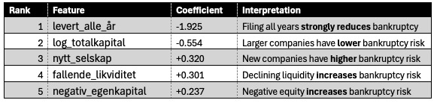
Table 1 - Top 10 Most Important Feature
This makes sense when connected to literature we found, and what our preconceptions were. We went on to perform multiple test models on the datasets, both supervised and unsupervised. Some of those were:
- Unsupervised only 2018 (All data)
- Unsupervised learning K-means + DBscan + PCA (All data)
- Unsupervised learning K-means + PCA (All years, only financial data)
These trials revealed some errors in data which we rectified where possible. One problem was overfitting in all of the models, because of the limited amount of data per sector.
These trials showed us positive results in that they showed possibilities, gave us better direction and helped in guiding our way forward. Because of these results, we decided on final analysis being on only the sectors mentioned earlier, and only on financial data. Both raw data and the key financial indicators. The results with the following models were also given to claude to help create reports of the resuls we got. We have combined those reports with our own analysis of the results.
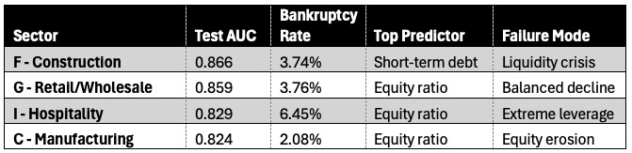
Table - Key Cross-Industry Findings
In table 2 we can see as we expected that the failure modes are different for each industry. This result also shows us that the bankruptcy rates the model found are similar to what we expect. What is interesting is that the top predictor for ¾ industries are similar. This shows that those industries fail because of similar economic conditions, but on more extreme ends.
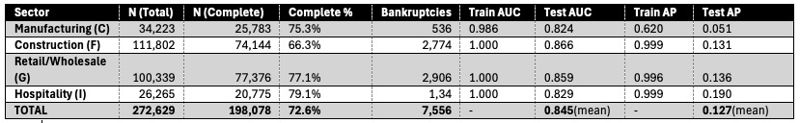
Table 3 - Model Performance Metrics
What we see in table 2 is that the model has an average completion rate over 70% which we deem satisfactory. Also see from the AUC scores that the performance is consistent, as all the results are within 0.042 of each other. One problem is that as can be seen from the Train AUC scores that the model is likely suffers from overfitting.
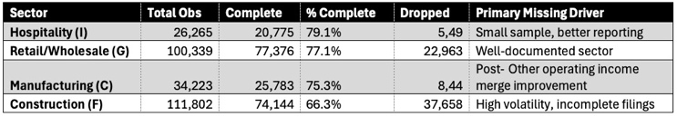
Table – Complete Case Analysis
Previously Manufacturing suffered from an error in the data, but this was solved after an improvement to the merge of Tall 7709 which was one of the identifiers in the data. This shows that when the data cleaning and sorting steps are not done properly errors can ripple through. Otherwise, the results show that more documentation leads to better results, as is lacking in the data from the constructions sector. We have not gone in depth to research why this is, but worth keeping in mind for future research.
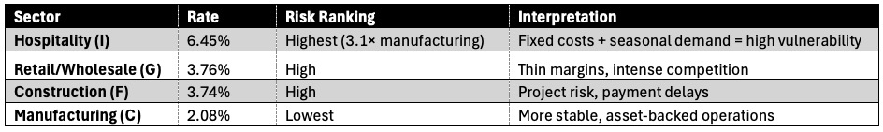
Table - Baseline Bankruptcy Rates
As per table 4, we found that baseline bankruptcy rates vary across the four sectors. Hospitality shows the highest failure rate at 6.45%, represent 3.1 time that of Manufacturing’s 2.08% baseline. This reflects challenges in hospitality like high fixed costs (rent, staff) combined with varying seasonal demand and thin margins. Construction and retail are at a middle ground of sorts, with 3.74% and 3.76% respectively. This can be explained by how construction has a project-based cash flow, and how retail faces competition and margin compression.
Manufacturing lower 2.08% rate shows greater operational stability. Asset-backed businesses, with well-established processes for production, and a diversified customer base shows a more resilient economic profile. However, this creates challenges in probability calibration, as rare events become difficult to predict without systemic overestimation.
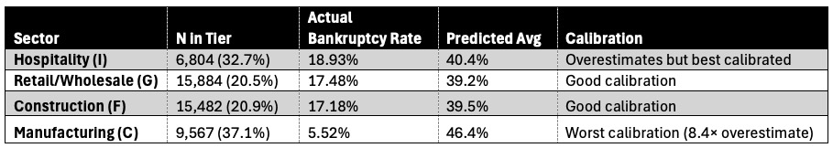Table - Very High Risk Tier Analysis (20%+ predicted probability)
The very high risk tier (companies with bankruptcy probabilities over 20%) shows strong discriminatory power while showing important sector-specific calibration patterns. This tier captures 95-98% of actual bankruptcies across all sectors, even though they only comprise 20-33% of all sector’s observations, showing the models ability to concentrate risk identification.
Actual bankruptcy rates within the very high tier go from 5.52% in manufacturing, to 18.93% in hospitality. Sector with higher baseline bankruptcy rates show better probability calibration, with construction (17.18% actual), retail (17.48% actual), and hospitality (18.93% actual), all show predicted-to-actual ratios around 2.1-2.3x. The model overestimates by a factor of around 2, which is acceptable for a class-weighted rare-event classifier. These sectors' higher base rates (3.7-6.5%) provide enough positive examples during training for more reliable probability estimation.
Manufacturing on the other hand faces a different calibration challenge. With a very high tier actual bankruptcy rate of only 5.52% vs. a 46.4% average predicted probability, the model shows an 8.4-fold overestimation. This miscalibration comes from the sector’s 2.08% baseline rate, meaning its extreme class imbalance (48:1 non-bankrupt to bankrupt ratio) forces the class-weighted Random Forest to inflate probabilities to achieve a good enough recall of the minority class. While this preserves the model’s ranking ability (AUC 0.82) it make raw probabilities unsuitable for direct interpretation.
These calibration patterns give a practical implication: deployment systems should employ discrete risk tier classifications rather than continuous probability thresholds. The very high tier represents a 5.5-19% bankruptcy risk depending on the sector, which is a substantial elevation which should trigger credit monitoring, but the 40-46% predicted probability should not be interpreted as literal failure likelihoods. The framework rather shows validated, actionable risk categories, while avoiding miscalibrated probabilities in an imbalanced classification context.
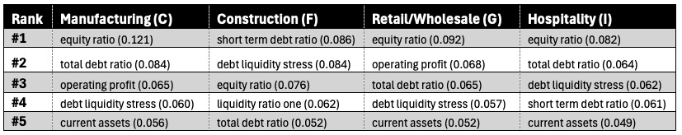
Table - Top Predictor Comparison
Feature importance analysis shows different bankruptcy drivers across sectors, validating the sector-specific modeling approach. Equity ratio (egenkapitalandel) is the most important predictor in three out of the four sectors with manufacturing (0.121), retail (0.092), and hospitality (0.082), where it shows 28-43% greater importance than the second-ranked predictor. This conforms with existing bankruptcy prediction theory (Altman, 1968; Ohlson, 1980), which identifies equity depletion through continuous operating losses as the primary mechanism of corporate failure.
Construction shows a divergence from this pattern. Short-term debt ratio (kortsiktig_gjeldsgrad) ranks first with an importance of 0.086, while equity ration comes in as the third ranked at 0.076. Liquidity-related features dominate construction's top five predictors: debt_liquidity_stress ranks second (0.084) and current ratio (likviditetsgrad_1) ranks fourth (0.062). This shows construction's unique economic structure. Project-based operations create payment timing mismatches where revenue does not come in until project completion, while material costs and labor expenses require upfront payment.
Seasonal factors contribute to this challenge, as winter weather reduces construction activity in Norway, while the businesses still have the same fixed costs. Payment chains through subcontractors also creates delays.
This sector heterogeneity has practical implications for credit risk assessment. Construction firms require liquidity monitoring, especially current ratios below 1.2 and rising short-term debt ratios, with reviews to capture rapid deterioration. Manufacturing, retail, and hospitality sectors need focus on equity trends and profitability metrics, with annual or semi-annual monitoring sufficient given slower failure progression. The feature importance rankings translate directly into sector-specific early warning frameworks based on each industry's economic situation.

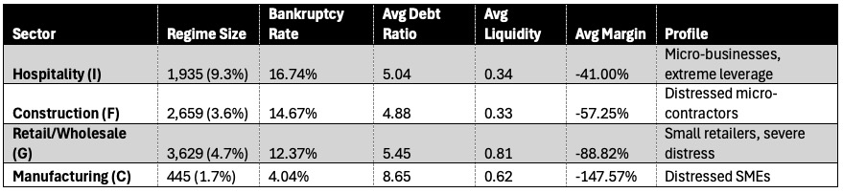
Table - Distressed Regime Comparison (Highest-Risk Cluster per Sector)
Table 7 is drawn from K-means clustering done one each specific sector, where this table takes the highest risk cluster from each. All variables are derived from the average within that cluster. This can give us a look into the some of the economies of the highest risk clusters. The average debt ratio shows us how much more debt they have to assets.
Average liquidity shows us on average how liquid they are. This tracks with our preconceptions of low liquidity being a major factor in businesses going bankrupt. Negative average margins suggest capital intensive operations with a cyclical nature.

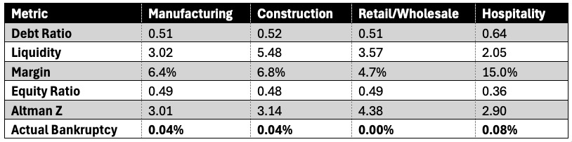
Table - Very Low Risk Tier (0-2% Predicted Probability)
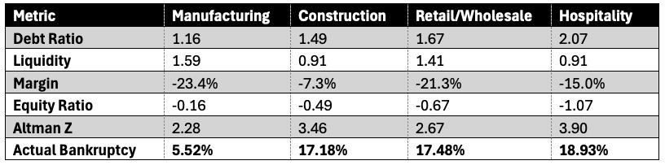
Table - Very High Risk Tier (20%+ Predicted Probability)
Both table 9 and 10 show the high and low end of the spectrum for the key financial indicators. These are both from the clustering done on each specific sector.

Discussion

Risks and Risk Mitigation
Overfitting, recall and accuracy are all factors which need to be considered when this sort of work is done. One problem we faced in this project was the risk of acquiring too little data. The sample size of companies in Norway is not that big when you look at it from a data perspective. In one single year some industries might be in the single digits when it comes to bankruptcies. We mitigated this risk by asking for all companies that started the bankruptcy process in the year 2019 and their 3 previous years of financial data. This was to ensure that if the sample size were to small, we could include more industry codes to ensure enough data.
Still, we ended up in a situation where even all this data was not enough to ensure that the models were not overfitting. This could be solved in future research by including more years in their data, more industries or by including countries with similar markets such as Sweden or Denmark.
Another main risk was that none of us mainly come from a discipline which has a deep understanding and common use of financial data and similar. We had some familiarity and used our contact network and AI tools to acquire some baseline knowledge to ensure that we could perform our testing. This risk could be solved in the future by involving economists or at least group members with a deeper understanding of the economics at work.

Discuss conceptual/ethical risks and implications.

Conclusion and Future work 0,4 S

Future work: Få inn en økonom, større data, flere år/flere land

References

List and number all bibliographical references in 9-point Times, single-spaced, at the end of your paper. When referenced in the text, enclose the citation number in square brackets, for example [1]. Where appropriate, include the name(s) of editors of referenced books. The template will number citations consecutively within brackets [1]. The sentence punctuation follows the bracket [2]. Refer simply to the reference number, as in [3]—do not use “Ref. [3]” or “reference [3]” except at the beginning of a sentence: “Reference [3] was the first . . .”

Altman, E. I. (1968). Financial Ratios, Discriminant Analysis and the Prediction of Corporate Bankruptcy. The Journal of Finance, 23(4), 589–609. https://doi.org/10.1111/j.1540-6261.1968.tb00843.x
Back, B., Laitinen, T., & Sere, K. (1996). Neural networks and genetic algorithms for bankruptcy predictions. Expert Systems with Applications, 11(4), 407–413. https://doi.org/10.1016/S0957-4174(96)00055-3
Beaver, W. H. (1966). Financial Ratios As Predictors of Failure. Journal of Accounting Research, 4, 71–111. https://doi.org/10.2307/2490171
Bell, E., Bryman, A., & Harley, B. (2022). Business research methods (Sixth edition). Oxford University Press.
Brønnøysundsregisteret. (2025, January 12). About Us. The Brønnøysund Register Centre. https://www.brreg.no/en/about-us-2/
Chen, N., Ribeiro, B., & Chen, A. (2016). Financial credit risk assessment: A recent review. The Artificial Intelligence Review, 45(1), 1–23. https://doi.org/10.1007/s10462-015-9434-x
Dakovic, R., Czado, C., & Berg, D. (2010). Bankruptcy prediction in Norway: A comparison study. Applied Economics Letters, 17(17), 1739–1746. https://doi.org/10.1080/13504850903299594
Ohlson, J. A. (1980). Financial Ratios and the Probabilistic Prediction of Bankruptcy. Journal of Accounting Research, 18(1), 109–131. https://doi.org/10.2307/2490395
Platt, H. D., & Platt, M. B. (1990). Development of a Class of Stable Predictive Variables: The Case of Bankruptcy Prediction. Journal of Business Finance & Accounting, 17(1), 31–51. https://doi.org/10.1111/j.1468-5957.1990.tb00548.x

